We need to register middleware in kernel

We actually restict the user to do some action

Php artisan make:middleware name

It is the layer bw request and response means a request has to go through the midlleware

For the registration

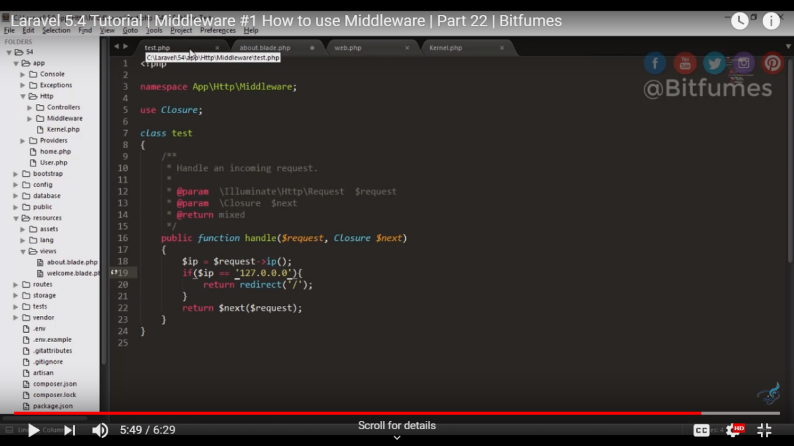

2

By using middleware here means we are assigning the middleware to the whole page we don’t need to assign middleware individually.

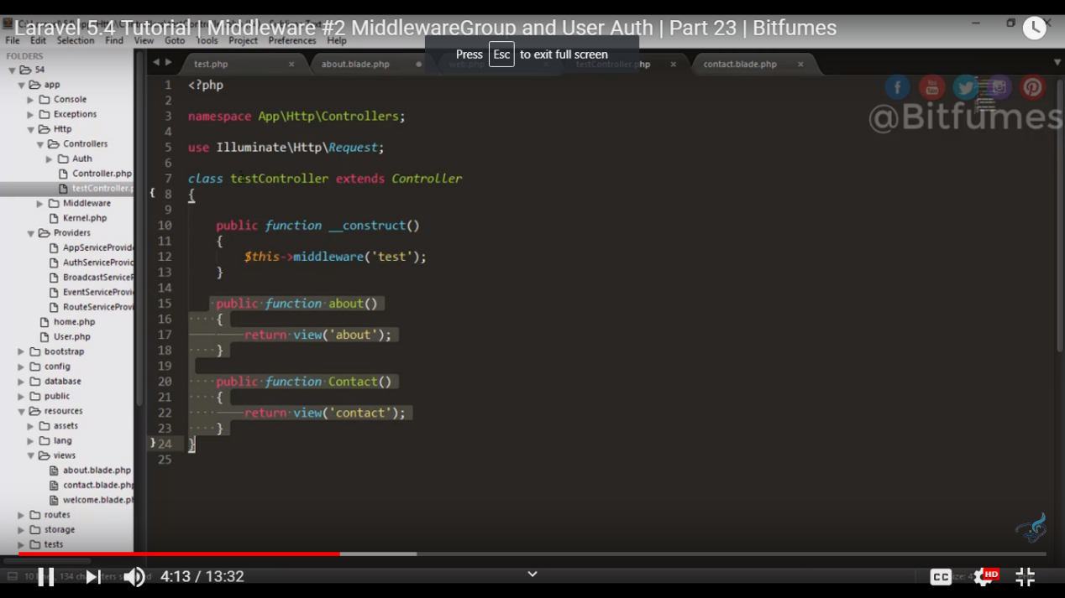

3

We can asssign mutiple middleware by using key and value pair .inside the middllewareGroup

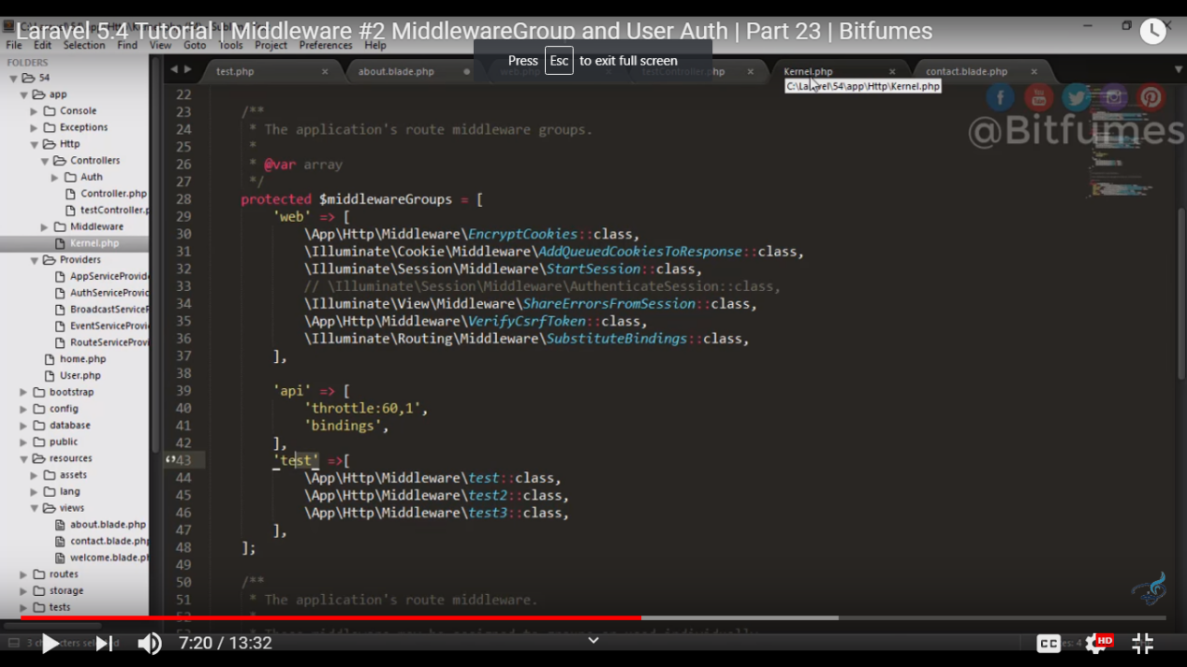

3

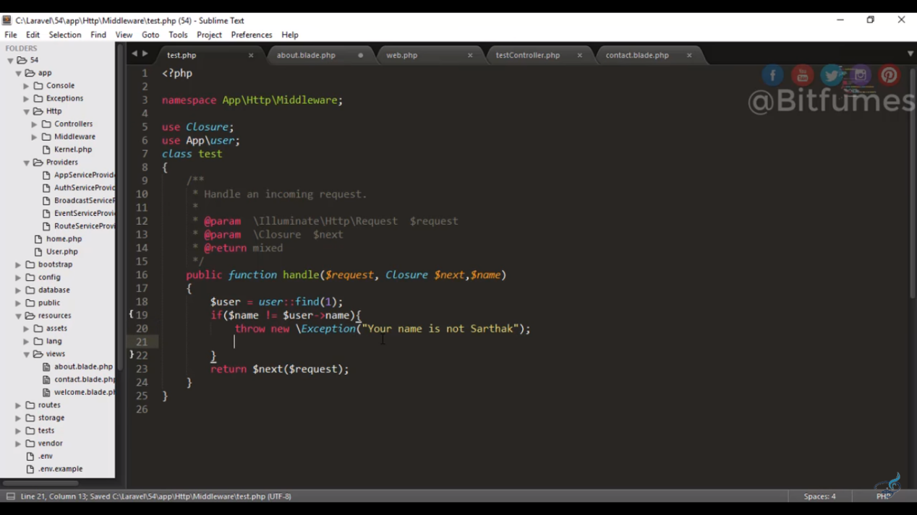

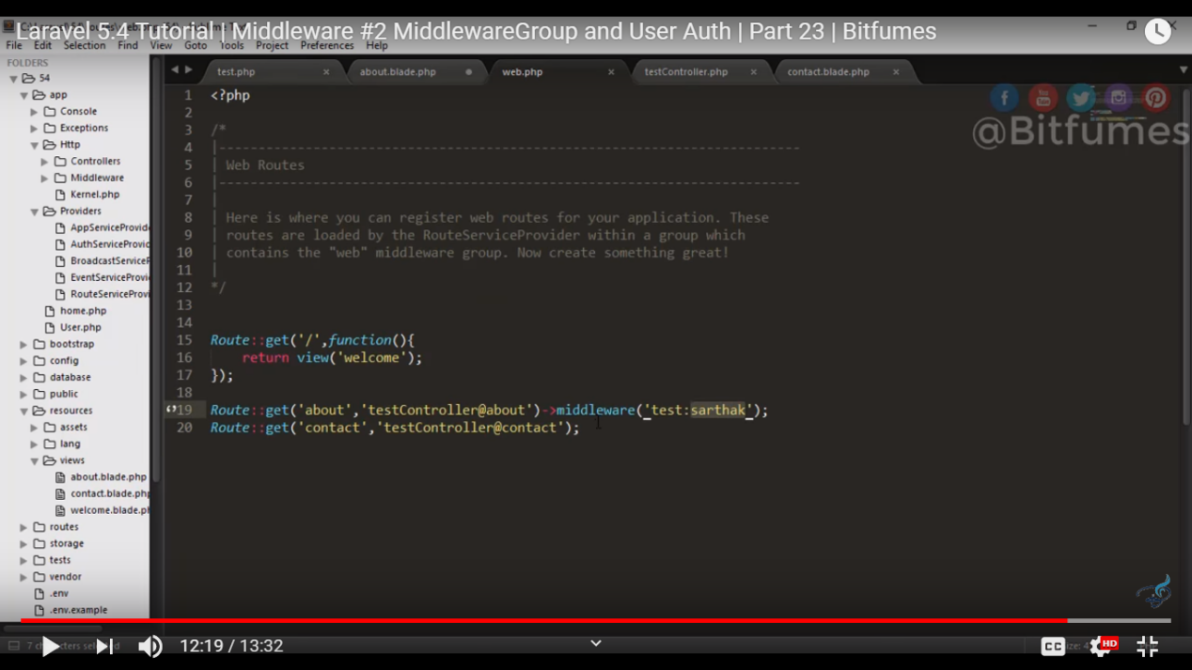

In this laravel 5.7 tutorial we will learn how to use session with laravel. we will use get, put and flash session with simple example

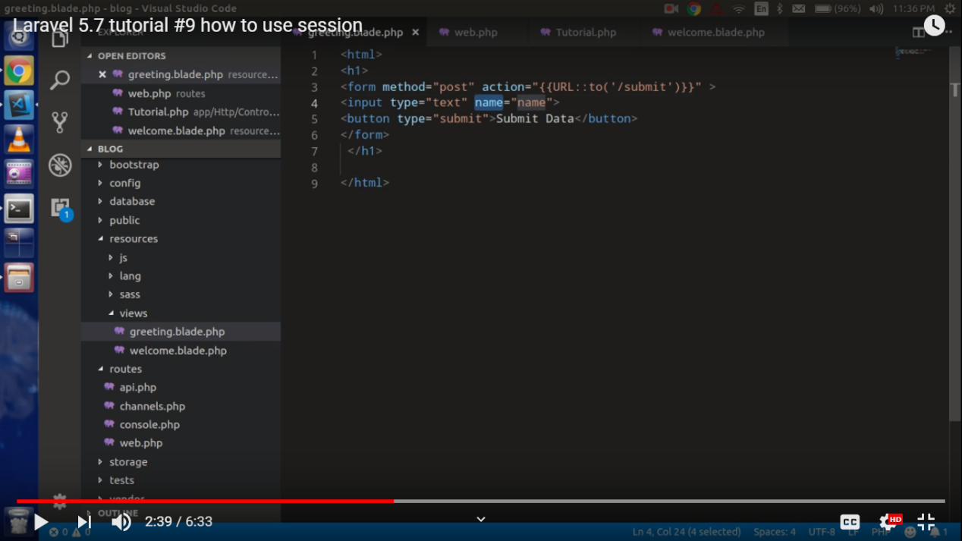

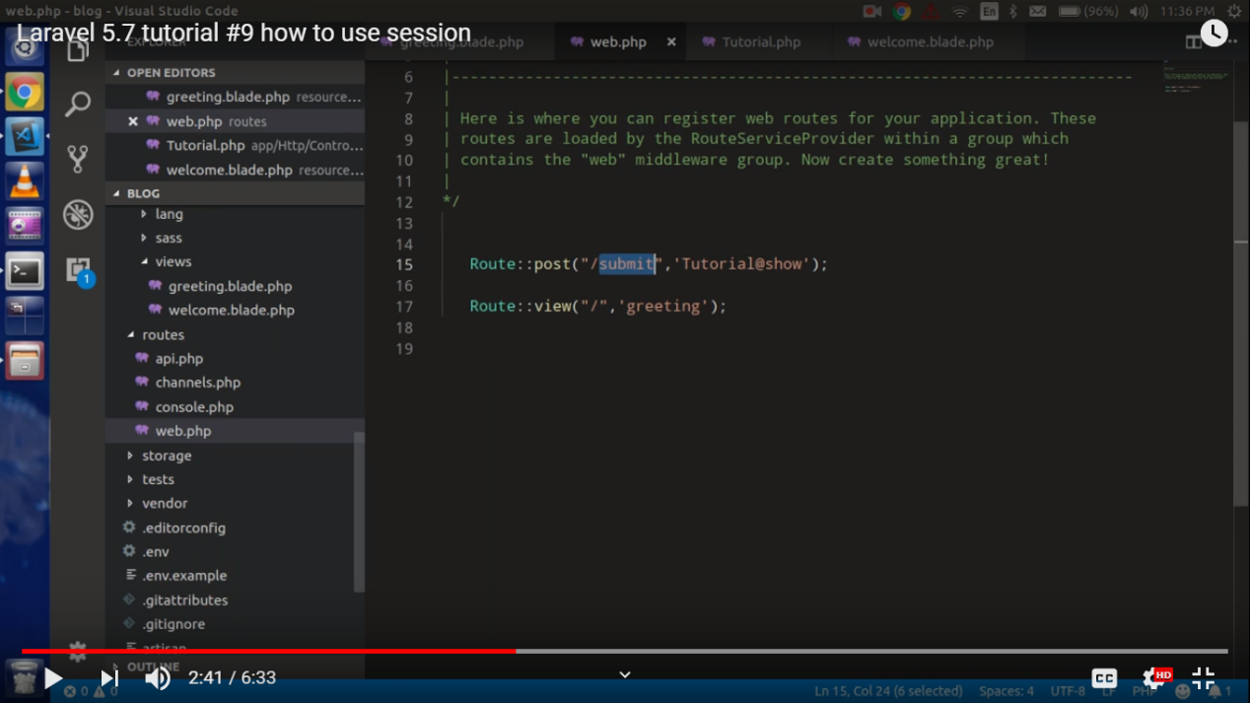

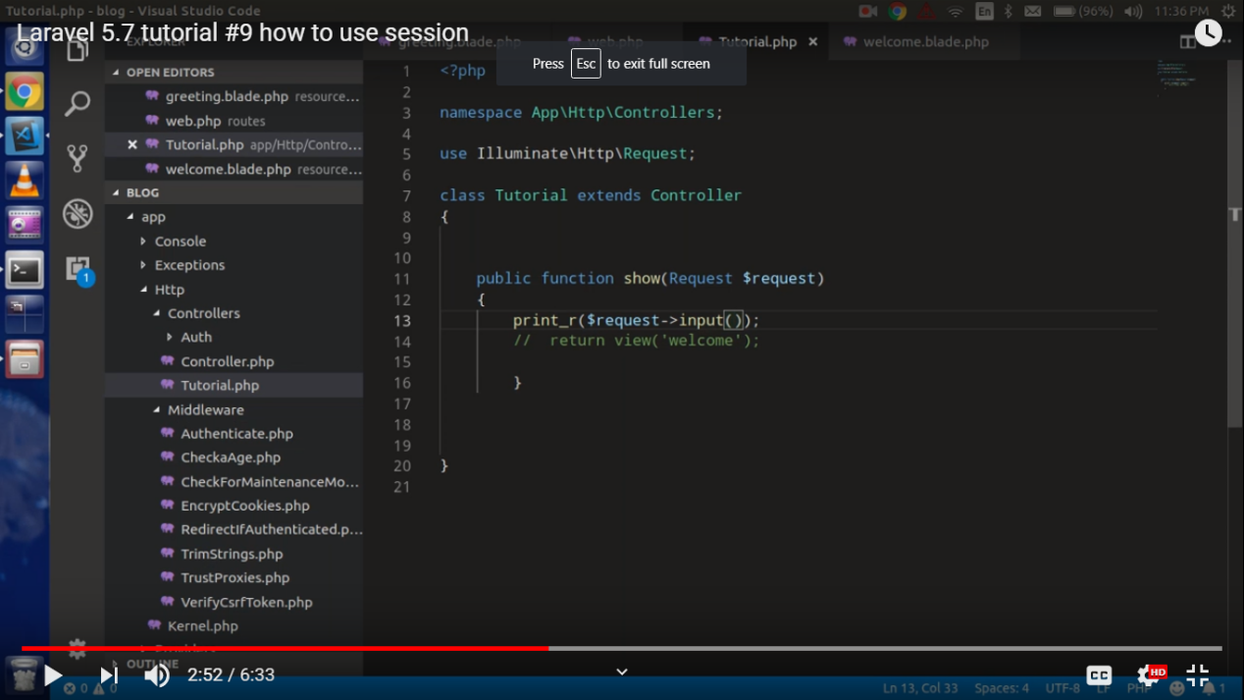

Or

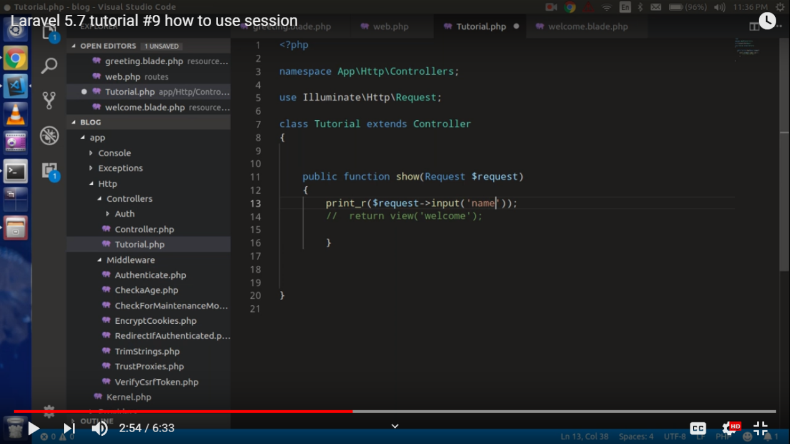

Result

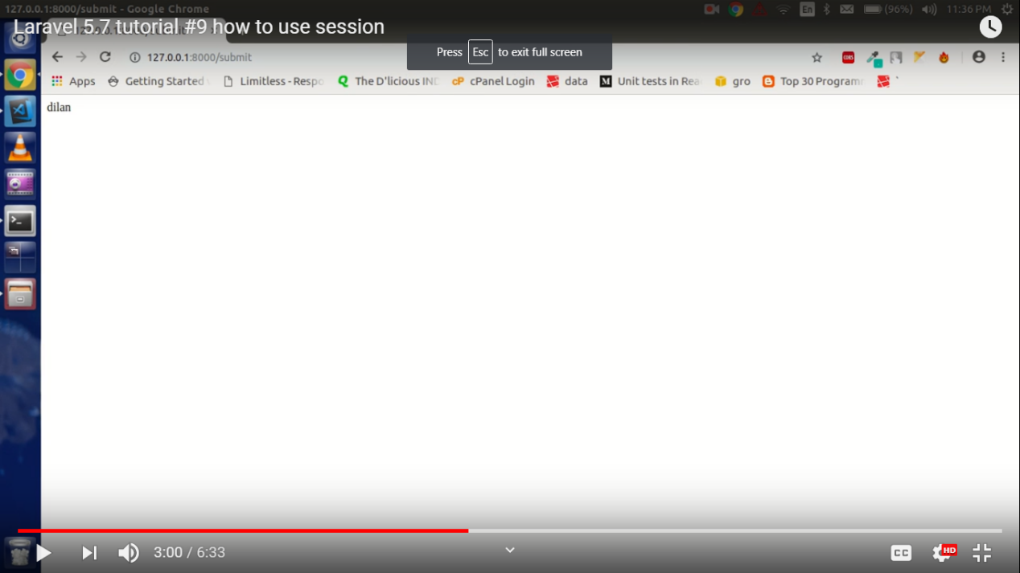

Now to store data in the session

We will use put()

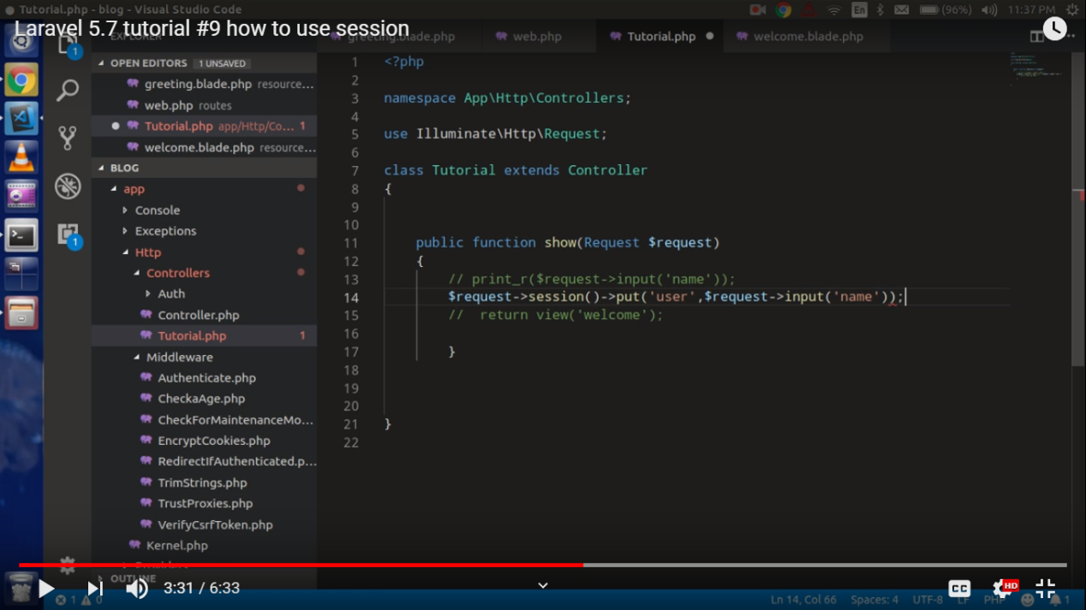

To get the data we will use get() method and and we will use the session key

Now to bind to the view

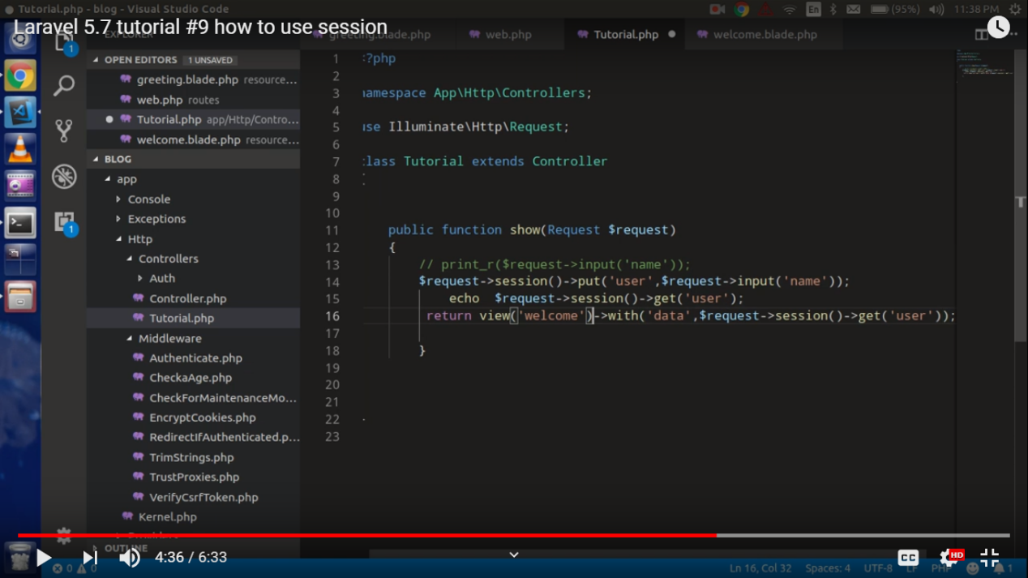

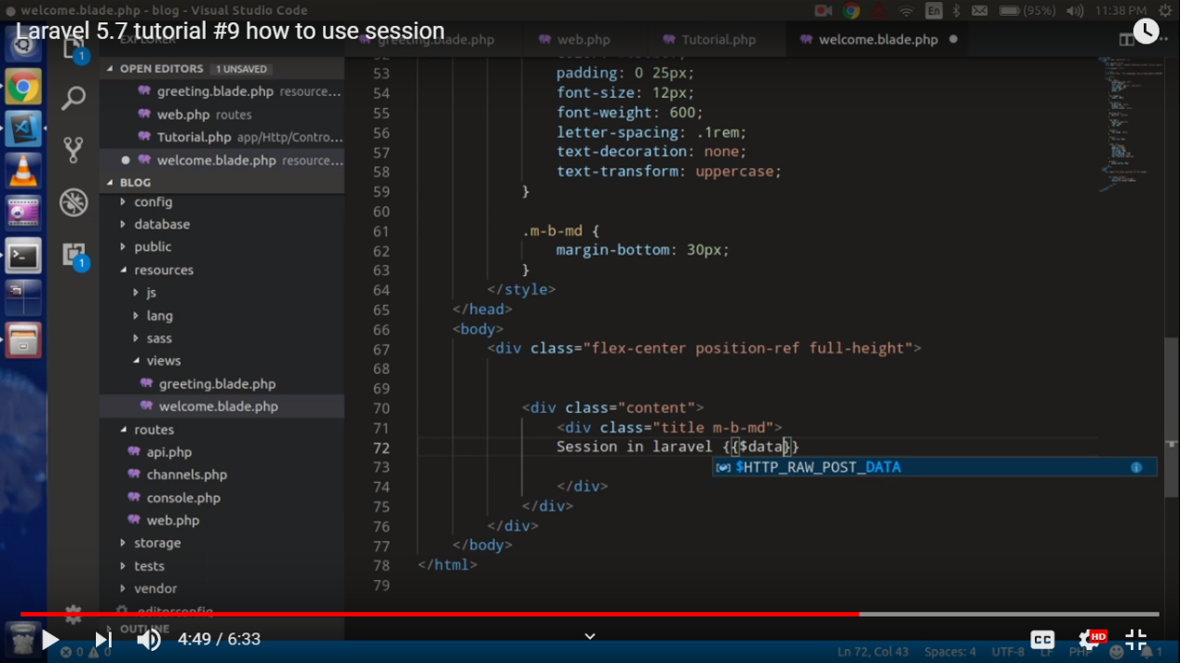

Flash() takes the data only once

